Aim: write a program to polymorphism and method overriding
A.1. polymorphism:
Input:
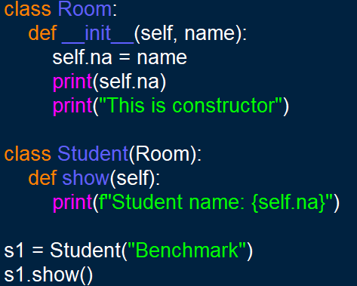
Output:


2. Constructor Overriding (Without super())
Input: OUPUT:
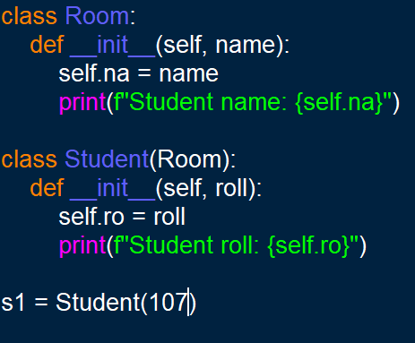
3. Constructor Overriding (With super()):
Input:
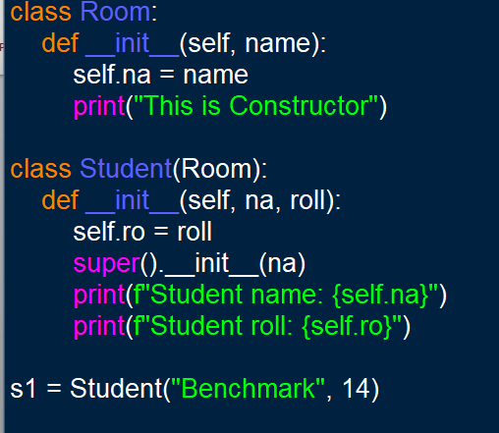
Ouput:

B. Overriding Constructor
Input:
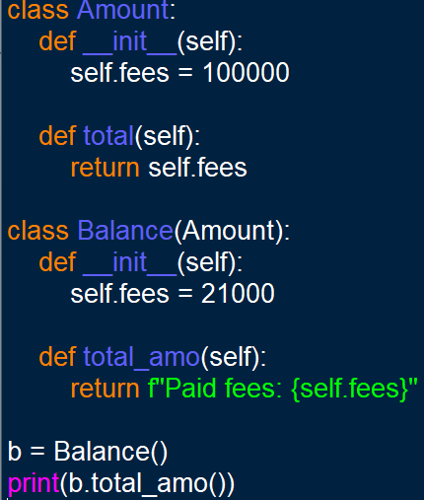
OUPUT:

C.Method overriding:
Input:
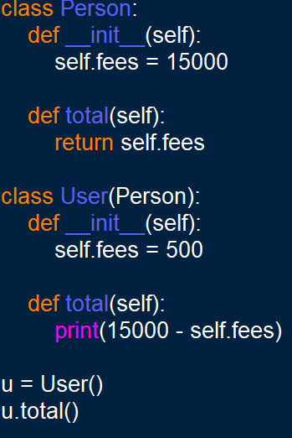
OUTPUT:


